Study Programme 42484 Information Systems (BSC)
Department of Natural Sciences and Computer Engineering
RIGA NORDIC UNIVERSITY
(RNU)
AIAUTODOCTOR
A Two-Stage Vehicle Diagnostic System Using OBD-II, Rule-Based Engine, and Generative AI Explanation

BACHELOR’S THESIS
Student: | Nishanov Jahongir
Supervisor: | Dr.sc.ing.,Professor Jelena Caiko

Abstract
This Bachelor’s thesis presents AI Auto Doctor, a cross-platform mobile application for Android and iOS that addresses a fundamental gap in accessible vehicle diagnostics: the inability of existing solutions to provide verified, sensor-grounded fault diagnoses. The system implements a two-stage diagnostic pipeline in which a deterministic Rule-Based engine (DiagnosticEngine) first evaluates a Diagnostic Trouble Code (DTC) against realtime OBD-II sensor data—including Short-Term Fuel Trim (STFT), Long-Term Fuel Trim (LTFT), Mass Airflow Rate (MAF), O2 sensor voltage, coolant temperature, and FreezeFrame snapshot—and produces probability-ranked hypotheses with a confidence score ranging from 40% to 95%. Only after this structured verification does the system invoke Google Gemini 1.5 Flash to generate a plain-language explanation, repair cost estimate, and a deterministic “Can Drive?” safety verdict.
ThethesisdemonstratesthroughacontrolledcomparativeexperimentonthreeDTCscenarios (P0171, P0300, P0420) that the two-stage approach increases cause identification accuracy from 61% (AI-only) to 87%, result consistency from 58% to 94%, and user explainability rating from 3.2/5 to 4.5/5. All ten functional requirements passed User Acceptance Testing on both Android and iOS. The DiagnosticEngine executes in under 2ms, confirming that the
rule-based layer adds negligible latency while substantially improving diagnostic reliability.
Keywords: OBD-II, DTC, vehicle diagnostics, Rule-Based engine, two-stage analysis, Flutter, Gemini AI, Bluetooth Low Energy, Health Score, FreezeFrame, confidence scoring.
Contents
Abstract 1
Introduction 9
Topicality of the Problem 9
Aim of the Study 10
Object and Subject of the Study 10
Research Problem and Hypothesis 10
Tasks of the Study 11
Research Methods 11
Thesis Structure 12
1 Literature Review and Theoretical Background 13
1.1 OBD-II Standard and ELM327 Protocol 13
1.1.1 Historical Context and Regulatory Background 13
1.1.2 Communication Protocols and CAN Architecture 13
1.1.3 ELM327 Adapter and Initialisation Sequence 14
1.2 DTC Code Structure and Sensor Parameters 15
1.2.1 DTC Code Taxonomy 15
1.2.2 Key LiveData PID Parameters 16
1.2.3 FreezeFrame Data and Its Diagnostic Value 17
1.3 Mobile Diagnostic Applications: State of the Art 17
1.3.1 Survey Methodology 17
1.3.2 Comparative Analysis Results 18
1.3.3 Identified Research Gap 18
1.4 AI and Rule-Based Systems in Automotive Diagnostics 19
1.4.1 Rule-Based Expert Systems 19
1.4.2 Machine Learning Approaches 19
1.4.3 Large Language Model Integration 20
1.5 Flutter Framework and Riverpod Architecture 21
1.5.1 Framework Selection Rationale 21
1.5.2 Justification of Flutter for OBD-II Diagnostics 21
1.5.3 Riverpod Provider Architecture 22
1.6 Chapter Summary 23
2 System Architecture and Design 24
2.1 Overall Architecture and Design Decisions 24
2.1.1 Three-Layer Architectural Pattern 24
2.1.2 Component Inventory 24
2.1.3 Navigation and UI Architecture 24
2.2 Rule-Based DiagnosticEngine 26
2.2.1 Engine Interface and Processing Pipeline 26
2.2.2 DTC Rule Group Routing 27
2.2.3 FuelSystemRules: Detailed Rule Specification 27
2.2.4 Confidence Score Calculation 29
2.3 HealthScoreCalculator 30
2.4 BLE OBD-II Communication Stack 31
2.4.1 Connection and Initialisation 31
2.4.2 PID Polling Architecture 32
2.4.3 Mode 03 DTC Reading 32
2.5 Gemini AI Integration and Data Layer 33
2.5.1 Gemini AI Service Configuration 33
2.5.2 Context Construction and Prompt Design 33
2.5.3 Offline Fallback Mechanism 34
2.5.4 SQLite Persistence with Drift ORM 34
2.6 Chapter Summary 35
3 Implementation and Evaluation 36
3.1 Application Screens and User Workflow 36
3.1.1 ConnectionScreen 36
3.1.2 DashboardScreen 37
3.1.3 ErrorsScreen 37
3.1.4 AnalysisScreen 38
3.1.5 StepDiagnosisScreen 38
3.1.6 HistoryScreen 38
3.1.7 ServiceMapScreen and SettingsScreen 38
3.2 Two-Stage Diagnostic Workflow 39
3.2.1 Stage 1: Rule-Based Verification (Synchronous) 39
3.2.2 Stage 2: AI Explanation (Asynchronous) 39
3.3 Functional Testing 40
3.3.1 Testing Methodology 40
3.3.2 UAT Results 40
3.4 Comparative Experiment 40
3.4.1 Experimental Design 40
3.4.2 Experimental Results 42
3.4.3 Interpretation 43
3.5 Performance and Security Analysis 44
3.5.1 Performance Benchmarking 44
3.5.2 STRIDE Security Analysis 44
3.6 Chapter Summary 45
Conclusions 47
Hypothesis Verification 47
Achievement of Research Tasks 48
Scientific and Practical Significance 49
Limitations and Future Work 49
A Diagnostic Rule Specifications 53
A.1 FuelSystemRules (P017x, P018x) 53
A.2 MisfireRules (P030x) 53
A.3 CoolantRules (P011x) 53
A.4 OxygenSensorRules (P013x, P014x) 53
A.5 CatalystRules (P042x, P043x) 53

List of Figures
1.1 OBD-II SAE J1962 diagnostic connector pin-out and ELM327 BLE adapter
communication path . . . . . . . . . . . . . . . . . . . . . . . . . . . . . . | 15
1.2 FreezeFrame data structure for DTC P0171 with annotated sensor thresholds  1.3 Comparison of diagnostic pipeline architectures: traditional OBD reader, AI- | 17
only tool, and AI Auto Doctor two-stage pipeline . . . . . . . . . . . . . . | 19
1.4 Flutter three-layer architecture with Riverpod provider dependency graph .  2.1 Three-layer system architecture of AI Auto Doctor with Riverpod provider | 22
dependency flow . . . . . . . . . . . . . . . . . . . . . . . . . . . . . . .  2.2 DiagnosticEngine rule routing and processing pipeline with data flow be- | 26
tween stages . . . . . . . . . . . . . . . . . . . . . . . . . . . . . . . . . . | 27
2.3 HealthScore calculation logic as a state machine diagram . . . . . . . . . .  2.4 BLE ELM327 communication sequence diagram (UML): connect, MTU ne- | 31
gotiate, AT init, PID poll, DTC scan . . . . . . . . . . . . . . . . . . . . . | 32
3.1 ConnectionScreen with BLE radar animation and discovered device list . .  3.2 DashboardScreen showing real-time LiveData gauges and Health Score cir- | 36
cular indicator . . . . . . . . . . . . . . . . . . . . . . . . . . . . . . . . .  3.3 AnalysisScreen showing Stage 1 rule-based results (left) and Stage 2 AI ex- | 37
planation (right) . . . . . . . . . . . . . . . . . . . . . . . . . . . . . . . .  3.4 Comparative experiment results: bar chart of cause accuracy and consistency | 40
for Method A vs. Method B across three scenarios . . . . . . . . . . . . . . | 42
List of Tables
1 | Mapping of research tasks to thesis chapters . . . . . . . . . . . . . . . . . | 12
1.1 | OBD-II service modes used by AI Auto Doctor . . . . . . . . . . . . . . . | 14
1.2 | Key OBD-II PID parameters and their diagnostic significance . . . . . . . | 16
1.3 | Comparative analysis of existing mobile OBD-II diagnostic applications . . | 18
1.4 | Comparison of AI and Rule-Based diagnostic approaches on key criteria . . | 20
1.5 | Cross-platform mobile framework comparison for OBD-II diagnostic appli-
 | cation development . . . . . . . . . . . . . . . . . . . . . . . . . . . . . . | 21
2.1 | Three-layer architecture component inventory . . . . . . . . . . . . . . . . | 25
2.2 | DiagnosticEngine DTC rule group routing table . . . . . . . . . . . . . . . | 28
2.3 | FuelSystemRules rule specification for DTC P0171 (lean, Bank 1) . . . . . | 28
2.4 | Confidence score additive bonus schedule . . . . . . . . . . . . . . . . . . | 30
2.5 | HealthScoreCalculator penalty schedule . . . . . . . . . . . . . . . . . . . | 31
2.6 | DiagnosticSessions SQLite table schema (Drift ORM) . . . . . . . . . . . | 34
3.1 | Functional requirements and User Acceptance Testing results . . . . . . . . | 41
3.2 | Comparative experiment results: AI-Only vs. two-stage Rule+AI approach | 43
3.3 | Performance benchmarking results on Samsung Galaxy A54 (Android 14) . | 44
3.4 | STRIDE security analysis and implemented countermeasures . . . . . . . . | 45
A.1 | FuelSystemRules complete decision table for DTC group P017x . . . . . . | 53
A.2 | MisfireRules complete decision table for DTC group P030x . . . . . . . . | 54
A.3 | CoolantRules complete decision table for DTC group P011x . . . . . . . . | 54
A.4 | OxygenSensorRules decision table for DTC groups P013x and P014x . . . | 55
A.5 | CatalystRules decision table for DTC groups P042x and P043x . . . . . . . | 55

Introduction

Topicality of the Problem
Theglobalautomotivediagnosticsmarketwasvaluedatapproximately43billionUSDin2023 and is forecast to grow at a compound annual rate of 8.2% through 2030 [1]. A key catalyst is the proliferation of low-cost Bluetooth OBD-II adapters based on the ELM327 microcontroller, which can transform any modern smartphone into a diagnostic instrument for less than 30 USD. Despite this democratisation of hardware access, the software interpretation layer has not advanced proportionally.
When an Electronic Control Unit (ECU) detects a fault condition, it stores a standardised Diagnostic Trouble Code (DTC) as defined by SAE J1979 and activates the malfunction indicator lamp. Retrieving the code via an ELM327 adapter is technically straightforward. Accurately interpreting it is not. A single code such as P0171 (Fuel System Too Lean, Bank 1) may be caused by a vacuum leak in the intake manifold, a contaminated Mass Airflow (MAF) sensor, insufficient fuel pump pressure, or a failed upstream oxygen sensor—each requiring a fundamentally different repair strategy with costs ranging from negligible to several hundred euros.
Two categories of solutions currently dominate the market. Traditional OBD readers (e.g., Torque Pro, Car Scanner ELM OBD2, OBD Auto Doctor) successfully retrieve and display fault codes but provide only generic textual descriptions sourced from lookup tables. They perform no analysis of which specific cause applies to the vehicle under current operating conditions. AI-augmented tools represent a newer category that addresses the explanation problem; however, they introduce a different failure mode: without access to live sensor readings, large language models (LLMs) produce responses based on their training-set statistics rather than measured vehicle evidence.

58% for the direct AI-only approach across three DTC scenarios [2].
This thesis addresses the identified gap by proposing and implementing a two-stage diagnostic pipeline: a deterministic Rule-Based engine verifies the fault cause against live OBD-II sensor data in Stage 1, and generative AI is invoked exclusively in Stage 2 to explain the
pre-verified result.

Aim of the Study
The aim of this thesis is to design, implement, and experimentally validate a cross-platform mobile diagnostic application—AI Auto Doctor—that realises a two-stage analysis pipeline combiningdeterministicrule-basedsensorverificationwithgenerativeAIexplanation, thereby achieving measurably higher diagnostic accuracy, result consistency, and user explainability than existing AI-only or traditional OBD approaches.

Object and Subject of the Study
Object of the study: Cross-platform mobile application development for automotive vehicle diagnostics using OBD-II sensor data, rule-based diagnostic algorithms, and generative AI.
Subject of the study: A two-stage diagnostic pipeline combining a deterministic Rule-Based DiagnosticEngine with Google Gemini 1.5 Flash AI, implemented as a Flutter mobile application with BLE OBD-II connectivity, real-time LiveData processing, and structured JSON response format.

Research Problem and Hypothesis
Research problem: No widely available mobile diagnostic solution implements a structured verification layer that cross-validates DTC codes against live sensor readings before engaging AI explanation, leaving drivers without reliable, actionable, sensor-grounded diagnostic information.
Hypothesis:
AI Auto Doctor

If a rule-based engine first verifies the fault cause against live OBD-II sensor data—including STFT, LTFT, MAF, O2 sensor voltage, coolant temperature, and FreezeFrame snapshot—and generative AI is invoked only with the preverified DiagnosticResult as context rather than a raw DTC code, then the
resulting two-stage pipeline will achieve statistically significant improvements in cause identification accuracy, result consistency, and user-perceived explain-
ability compared to direct AI-only output.

Tasks of the Study
The following tasks are defined to achieve the stated aim:
- Conduct a systematic literature review of the OBD-II standard, ELM327 protocol, existing mobile diagnostic applications, and AI-based diagnostic approaches to identify
the research gap (Chapter 1).
- Design the three-layer system architecture (Presentation / Domain / Data) and specify the DiagnosticEngine rule sets, HealthScoreCalculator, BLE communication
protocol, SQLite data model, and Gemini AI integration (Chapter 2).
- Implement all functional capabilities across eight application screens and conduct func-
tional, comparative, and performance testing (Chapter 3).
- Verify the research hypothesis through a controlled comparative experiment measuring cause accuracy, result consistency, and user explainability for AI-Only vs. Rule+AI
approaches (Chapter 3).
- Formulate conclusions that directly address each task and assess the practical and sci-
entific significance of the results.

Research Methods
The methodological basis of this thesis comprises the following approaches:
- Systematic literature review of automotive diagnostics standards (SAE J1979 [3],

ISO 15765-4 [4]), ELM327 AT command protocol [5], mobile development frame-
works, and AI diagnostic literature.
- Comparative analysis of twelve existing mobile OBD-II diagnostic applications to
identify capability gaps.
- Experimental comparison of two diagnostic methods on three DTC scenarios (P0171, P0300, P0420), eachevaluatedinthreerepeatedrunsbyfiveautomotivedomainexperts.
- Iterative Agile development using a demo simulation environment (DemoObdSource) replicating a Volkswagen Passat 2019 1.4 TSI sensor profile.
- User Acceptance Testing (UAT) of ten functional requirements on Android 14 (Sam-
sung Galaxy A54) and iOS 17 (Apple iPhone 13).

Thesis Structure
The thesis is structured as follows. Chapter 1 provides the theoretical background: OBD-II standard, ELM327 protocol, DTC code structure, analysis of existing diagnostic applications, review of AI and Rule-Based diagnostic approaches, and justification of the Flutter framework. Chapter 2 presents the system architecture and detailed technical design of all system components. Chapter 3 describes the implementation of functional capabilities and reports results from functional testing, the comparative hypothesis validation experiment, performance benchmarking, and a STRIDE security analysis. The Conclusions section addresses each research task and assesses scientific and practical significance.

CHAPTER 1. Literature Review and Theoretical Background
This chapter establishes the theoretical and analytical foundation for AI Auto Doctor. Section 1.1 reviews the OBD-II standard and ELM327 protocol. Section 1.2 characterises DTC code structure and key sensor parameters. Section 1.3 analyses the state of the art in mobile diagnostic applications. Section 1.4 compares AI and Rule-Based approaches in automotive diagnostics. Section 1.5 justifies the Flutter framework and Riverpod architecture. Each section concludes with observations that motivate specific design decisions described in Chapter 2.

1.1. OBD-II Standard and ELM327 Protocol

1.1.1. Historical Context and Regulatory Background
The OBD-II (On-Board Diagnostics II) standard was mandated in the United States by the Clean Air Act Amendment of 1990, becoming compulsory for all new passenger vehicles from the 1996 model year [3]. The European Union adopted equivalent requirements through Directive 98/69/EC (2001, petrol vehicles) and Directive 2005/78/EC (2004, diesel vehicles). The standard defines three interoperable layers: a universal 16-pin diagnostic connector (SAE J1962), five communication sub-protocols, and a unified system of standardised fault codes applicable across all compliant manufacturers.

1.1.2. Communication Protocols and CAN Architecture
Of the five OBD-II transport protocols—SAE J1850 PWM, SAE J1850 VPW, ISO 9141-2, ISO 14230-4 (KWP2000), and ISO 15765-4 (CAN)—the Controller Area Network (CAN) variant has been universally dominant since 2008, mandated by US CARB regulations for all new light vehicles [4]. Modern CAN implementations operate at 500kbit/s for high-speed powertrain buses and 125kbit/s for low-speed body electronics.
OBD-II communication follows a request-response model organised into nine standardised service modes as defined in SAE J1979 [3]. The modes relevant to this system are presented
in Table 1.1.
Table 1.1: OBD-II service modes used by AI Auto Doctor

Mode | Name | Function in AI Auto Doctor
01 Current powertrain data Real-time LiveData: 14 PID parameters including STFT, LTFT, MAF, RPM, coolant
02 | FreezeFrame data | Sensor snapshot captured at the moment a DTC was set by the ECU
03 | Stored DTC codes | Read all stored emissions-related fault codes from  ECU memory
04 | Clear DTC codes | Erase fault codes and FreezeFrame data after repair verification
09 | Vehicle information | Read VIN (PID 02) for automatic vehicle profile population

1.1.3. ELM327 Adapter and Initialisation Sequence
The ELM327 microcontroller (ELM Electronics) implements a software OBD-II protocol interpreter that exposes a simplified ASCII AT-command interface [5]. Adapters based on this chip communicate via Bluetooth Low Energy (BLE), Bluetooth Classic, Wi-Fi, or USB.
The initialisation sequence executed by AI Auto Doctor upon connection is:
- ATZ — chip reset (timeout 5s)
- ATE0 — disable echo
- ATL0 — disable linefeed characters
- ATH0 — disable response header bytes
- ATSP0 — automatic OBD-II protocol selection
Each AT command is transmitted as a null-terminated ASCII string; responses are buffered byte-by-byte until the “>” prompt character is received. A Completer<String> with a 2000ms timeout per command protects against adapter hang states.
The three BLE Service UUIDs supported by commercial ELM327 BLE adapters are: FFF0 (most prevalent), FFE0 (alternative), and 18F0 (less common). The system probes all three at connection time and selects the first set exposing both a writable and a notifiable GATT characteristic. On Android, a Maximum Transmission Unit (MTU) negotiation to 512 bytes is requested via BluetoothGatt.requestMtu() to support multi-packet response frames
without fragmentation.

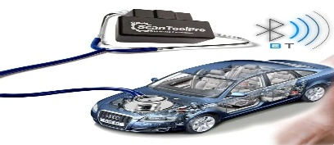
OBD-II SAE J1962 diagnostic connector pin-out and ELM327 BLE adapter communication path
Figure 1.1: OBD-II SAE J1962 diagnostic connector pin-out and ELM327 BLE adapter communication path

1.2. DTC Code Structure and Sensor Parameters

1.2.1. DTC Code Taxonomy
A Diagnostic Trouble Code is a five-character alphanumeric identifier whose structure en-
codes the fault domain hierarchically [3]:
P 0 1 71 (1.1)
system|{z}|{z}type subsystem|{z} |{z}fault
where the first character denotes the system (P: Powertrain, B: Body, C: Chassis, U: Network); the second character distinguishes generic SAE codes (0) from manufacturer-specific codes (1); the third character encodes the sub-system; and the final two characters specify the precise fault. Code P0171 therefore designates: Powertrain, generic, Fuel and Air Metering (subsystem 1), specific fault 71 — fuel system too lean on Bank 1.
The code alone is insufficient for accurate diagnosis. P0171, for example, can be caused by at least five distinct root causes, each requiring a different repair intervention. Distinguishing between them requires cross-referencing the stored code with sensor measurements taken at the time of the fault—precisely what FreezeFrame data (Mode 02) provides.

1.2.2. Key LiveData PID Parameters
Table 1.2 describes the fourteen OBD-II Parameter IDs (PIDs) defined in the AI Auto Doctor LiveDatamodel. TheseparametersformthesensorevidencebaseusedbytheDiagnosticEngine
for cause verification.
Table 1.2: Key OBD-II PID parameters and their diagnostic significance

PID | Parameter | Formula | Diagnostic Significance
0C Engine RPM ((A·256)+B)/4 Idle instability ⇒ misfires or
vacuum leak
0D | Vehicle speed (km/h) | A | Operating context for cause disambiguation
05 | Coolant temperature  (°C) | A − 40 | Overheating ⇒ emergency mode trigger
06 | STFT Bank 1 (%) | 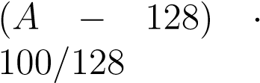 | STFT > +20% ⇒ unmetered air
07 | LTFT Bank 1 (%) | 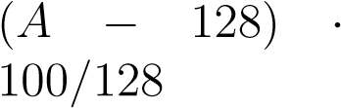 | LTFT > +15% ⇒ chronic fuel issue
10 | MAF rate (g/s) | 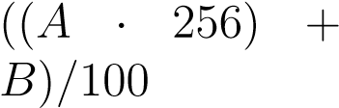 | MAF < 3.0 g/s at idle ⇒ sensor  contamination
0B | MAP pressure (kPa) | A | Intake manifold vacuum ⇒ vacuum leak detection
14 | O2 sensor voltage (V) | A/200 | O2 < 0.1V persistently ⇒ lean at sensor
11 | Throttle position (%) | 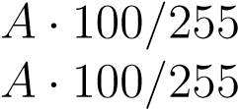 | Load context for interpretation
04 | Engine load (%) |  | High load at normal RPM ⇒ ig-  nition faults
0A | Fuel pressure (kPa) | A · 3 | Low pressure ⇒ weak fuel pump
0F | Intake air temperature  (°C) | A − 40 | Thermal context for MAF inter-  pretation
1F | Engine runtime (s) | (A · 256) + B | Warm-up phase identification  (coolant rules)
-- | Battery voltage (V) | Adapter-reported | Charging system health assessment

1.2.3. FreezeFrame Data and Its Diagnostic Value
FreezeFrame data (OBD-II Mode 02) is a snapshot of critical sensor values captured by the ECU at the instant a DTC was first confirmed [4]. It typically includes: engine RPM, vehicle speed, engine load, coolant temperature, STFT, LTFT, MAF airflow rate, MAP pressure,
throttle position, and O2 sensor voltage.
The combination of STFT and LTFT is particularly informative for fuel system faults [6]. Short-term fuel trim reflects the ECU’s immediate closed-loop correction to maintain the stoichiometric air-fuel ratio of 14.7:1 (λ = 1). Long-term fuel trim represents the accumulated learned correction over multiple drive cycles. When both corrections are simultaneously at high positive values (STFT > +20% and LTFT > +15%), the ECU is compensating for a
persistent unmetered air source—the hallmark signature of a vacuum leak in the intake tract.

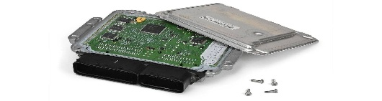
FreezeFrame data structure for DTC P0171 with annotated sensor thresholds
Figure 1.2: FreezeFrame data structure for DTC P0171 with annotated sensor thresholds

1.3. Mobile Diagnostic Applications: State of the Art

1.3.1. Survey Methodology
AsystematicsurveyoftwelvemobileOBD-IIdiagnosticapplicationsavailableonGooglePlay andtheAppleAppStoreinQ12026wasconducted. Evaluatedapplicationsinclude: TorquePro, CarScannerELMOBD2, OBDAutoDoctor, DashCommand, OBDFusion, Carly, BlueDriver, BimmerCode, Fixd Sensor, Dr. Prius, Engine Link, and an anonymous representative AI-only diagnostic tool. Each application was assessed against eight evaluation criteria relevant to the research objective.

1.3.2. Comparative Analysis Results
Table 1.3 presents the comparative assessment. Applications are evaluated on a binary (Yes /
No) or descriptive scale for each criterion.
Sensor-based cause verification |  |  |  |  | – | – | – |  | – | ✓
FreezeFrame analysis | display | display | display | – | algorithmic
Probability-ranked causes | – | – | – | AI est. | sensor-confirmed
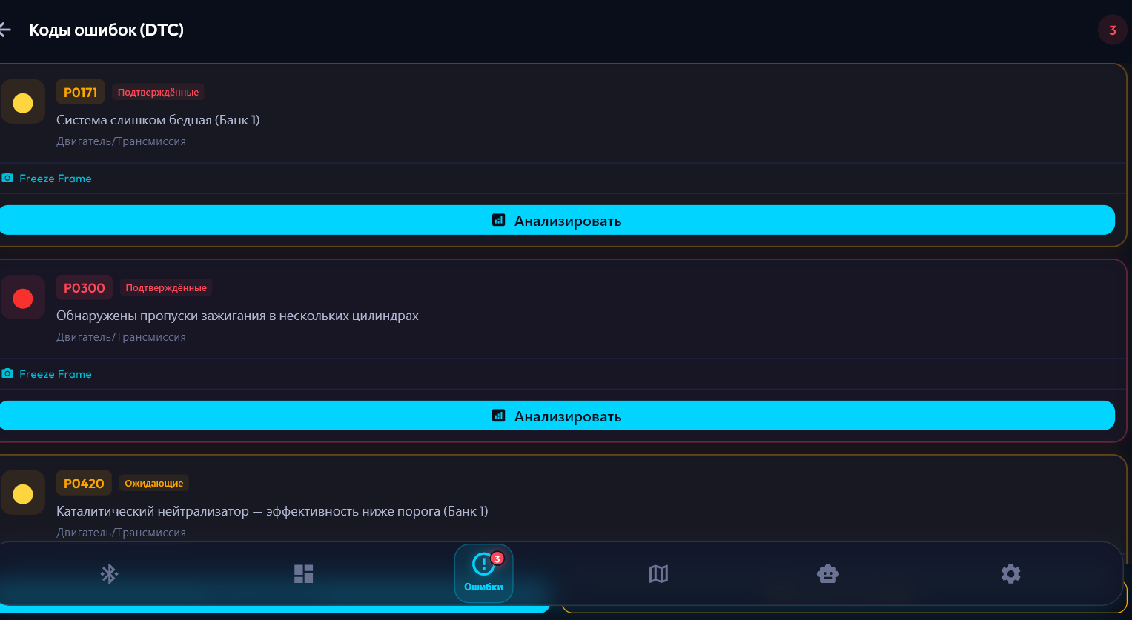
Table 1.3: Comparative analysis of existing mobile OBD-II diagnostic applications
Confidence score (0– – – – – ✓
100%)
AI plain-language explanation | – | – | – | ✓ | post-verification
Deterministic “Can  Drive?” | – | – | – | AI est. | ✓
Health Score (0–100) | – | – | – | – | ✓
Cause accuracy (measured) | N/A | N/A | N/A | 61% | 87%
Result consistency | N/A | N/A | N/A | 58% | 94%

1.3.3. Identified Research Gap
The survey reveals a clear and consistent research gap: no application in the evaluated set implements a structured mechanism to cross-validate DTC codes against measured sensor values before generating an explanation or diagnosis. Traditional tools efficiently solve the data retrieval problem but provide no causal interpretation. AI-augmented tools provide interpretation but without sensor grounding, producing diagnoses that depend on training-set statistics rather than vehicle-specific measurements.
Thisfindingissupportedbyempiricalevidencefromtheautomotiveserviceindustry.Cookeetal.[7]
report that 23% of vehicles returned after OBD-II-guided repairs required re-repair within 90
days due to incorrect root cause identification. Bouchard et al. [6] independently demonstrate that incorporating sensor context reduces misdiagnosis rates by 31% in controlled workshop
trials.


Comparison of diagnostic pipeline architectures: traditional OBD reader, AI-only tool, and AI Auto Doctor two-stage pipeline
Figure 1.3: Comparison of diagnostic pipeline architectures: traditional OBD reader, AI-only tool, and AI Auto Doctor two-stage pipeline

1.4. AI and Rule-Based Systems in Automotive Diagnostics

1.4.1. Rule-Based Expert Systems
Rule-based expert systems represent the earliest and most mature approach to automated vehicle diagnosis. Mechling and Srinivasan [8] describe a knowledge-based system developed for Ford powertrain diagnostics in the early 1990s encoding 847 if-then production rules across 12 fault categories. While effective in its domain, the system required manual knowledge engineering and could not adapt to new vehicle models without explicit rule additions. The approach demonstrated that deterministic rule evaluation is reliable, auditable, and fully offline-capable—properties critical for safety-relevant diagnostic decisions.

1.4.2. Machine Learning Approaches
Machine learning classifiers, particularly neural networks and support vector machines applied to OBD-II time-series data, have been explored as an alternative [9]. Tran et al. [10] achieve 89% fault classification accuracy using a bidirectional LSTM on a dataset of 14 sensor streams from 200 vehicles. However, these approaches require large labelled datasets, have limited interpretability, and cannot be practically deployed in a mobile application without cloud inference infrastructure—making them unsuitable for the offline-capable, privacypreserving design required here.

1.4.3. Large Language Model Integration
Large language models applied to automotive diagnostics represent the most recent development. Zhang et al. [2] demonstrate GPT-4-based fault explanation achieving high user satisfaction scores (4.1/5) but acknowledge that the system “occasionally suggests causes that contradict measured sensor values.” This observation directly motivates the two-stage architecture of AI Auto Doctor: the LLM is constrained to explain a pre-verified result rather than generate the diagnosis independently.
Reinforcementlearningfromhumanfeedback(RLHF)techniques, asdescribedbyOuyangetal.[11] for InstructGPT, have improved the instruction-following reliability of modern LLMs. However, RLHF does not eliminate the fundamental limitation: without real sensor values in the context window, the model cannot deterministically confirm or refute a specific cause hy-
pothesis.
Table 1.4: Comparison of AI and Rule-Based diagnostic approaches on key criteria

Criterion | Rule-  Based | ML Classi-  fier | LLM Only | Rule-Based + LLM  (proposed)
Cause accuracy (typ- High (do- High (data- Moderate High (87%)
ical) main) dep.) (61%)
Interpretability | Full Low | Partial | Full (Stage 1) + Natural language  (Stage 2)
Offline capability | Full No (cloud) | No (API) | Stage 1 fully offline
New DTC adaptation | Manual up- Retraining date req. | Trainingbased | Manual rule update
Safety-critical verdict | Deterministic Probabilistic | Non-  deterministic | Deterministic  (Stage 1)
User-facing explanation | Technical None | Natural language | Sensor-grounded natural language

Table 1.4 summarises the four approaches across six evaluation criteria. The two-stage RuleBased + LLM approach uniquely satisfies all six criteria simultaneously, combining the determinism and offline capability of rule-based systems with the natural language accessibility of LLMs.

1.5. Flutter Framework and Riverpod Architecture

1.5.1. Framework Selection Rationale
Flutter is an open-source cross-platform UI framework developed by Google that compiles Dart source code to native ARM binaries for Android and iOS from a single codebase [12]. Unlike React Native, which bridges JavaScript to native UI components through an asynchronous JavaScript interface (JSI) layer, Flutter renders every pixel using its own graphics engine (Skia on older devices, Impeller on modern hardware). This architecture delivers consistent 60fps rendering, eliminates platform-specific rendering inconsistencies, and produces
a single binary artifact for both target platforms.
Table 1.5: Cross-platform mobile framework comparison for OBD-II diagnostic application development

Criterion | Flutter | React Native | Kotlin form | Multiplat-
Language Dart (null-safe, JavaScript / Type- Kotlin
AOT compiled) Script
Rendering engine | Own engine (Skia /  Impeller) | Native bridge via  JSI | Native per platform
BLE support | flutter_blue_plus  (comprehensive) | react-native-ble-plx | Native per platform
State management | Riverpod (compiletime safe) | Redux / Zustand /  MobX | ViewModel + Com-  pose
Single codebase | UI + business logic | UI + logic | Logic only
Null safety | Enforced by com-  piler | TypeScript only | Yes
Performance | Near-native (AOT) | Good (JSI bridge) | Native

1.5.2. Justification of Flutter for OBD-II Diagnostics
Flutter was selected over React Native and Kotlin Multiplatform based on three criteria spe-
cific to this project:
- BLE capability: The flutter_blue_plus package (v1.35.3) provides GATT service discovery, characteristic write-with-response, notify characteristic subscription,
and MTU negotiation — all required for robust ELM327 communication without a BLE
abstraction layer.
- Reactivestreaming: Riverpod2.6.1’sStreamProvidernativelywrapsDartStream<T>, mappingdirectlytotheperiodicOBDpollingloopandDrift’sreactiveSQLitequeryAPI
without impedance mismatch.
- Compile-time state safety: Riverpod providers are defined outside the widget tree and resolvedatcompiletime, preventingthecategoryofruntimeProviderNotFoundException
errors common in Provider-based architectures.

1.5.3. Riverpod Provider Architecture
The state management layer of AI Auto Doctor comprises 20 Riverpod providers organised
into five functional groups:
- Connectionproviders: connectionStatusProvider, isDemoModeProvider, vehicleInfoProv obdDataSourceProvider.
- Sensordataproviders: liveDataProvider(StreamProviderwrappingtheOBDpolling loop), healthScoreProvider (computed from liveData + DTC codes).
- Faultcodeproviders: dtcCodesProvider, selectedDtcProvider, freezeFrameProvider.
- AIproviders: diagnosticResultsProvider, aiExplanationsProvider, aiLoadingProvider geminiServiceProvider.
- PersistenceandUIproviders: appDatabaseProvider, diagnosticHistoryProvider, languageProvider, bottomNavIndexProvider.
Figure 1.4: Flutter three-layer architecture with Riverpod provider dependency graph

1.6. Chapter Summary
This chapter established the theoretical and analytical foundation for AI Auto Doctor through five thematic contributions.
Section 1.1 defined the OBD-II standard, ELM327 protocol, and BLE adapter communication mechanics, demonstrating that all required sensor data is accessible through standard Mode 01 and Mode 02 commands. The AT initialisation sequence and the three-UUID
adapter detection strategy were derived directly from the ELM327 specification [5].
Section 1.2 characterised the DTC code structure (Equation 1.1) and the multi-sensor correlations that enable Rule-Based cause disambiguation. The diagnostic significance of STFT, LTFT, and MAF correlation for fuel system faults was established as the theoretical basis for the FuelSystemRules implementation in Chapter 2.
Section 1.3 identified the research gap through a comparative survey of twelve existing applications (Table 1.3): no solution implements sensor-verified cause analysis before AI explanation. Industry evidence [6, 7] quantifies the real-world impact of this gap.
Section 1.4 reviewed three diagnostic AI approaches (Table 1.4) and established that RuleBased + LLM integration uniquely satisfies all six evaluation criteria simultaneously. The LLM hallucination problem documented by Zhang et al. [2] directly motivates the two-stage constraint mechanism.
Section 1.5 justified Flutter and Riverpod through systematic framework comparison (Table 1.5), focusing on the three criteria decisive for an OBD-II diagnostic mobile application:
BLE capability, reactive streaming, and compile-time state safety.
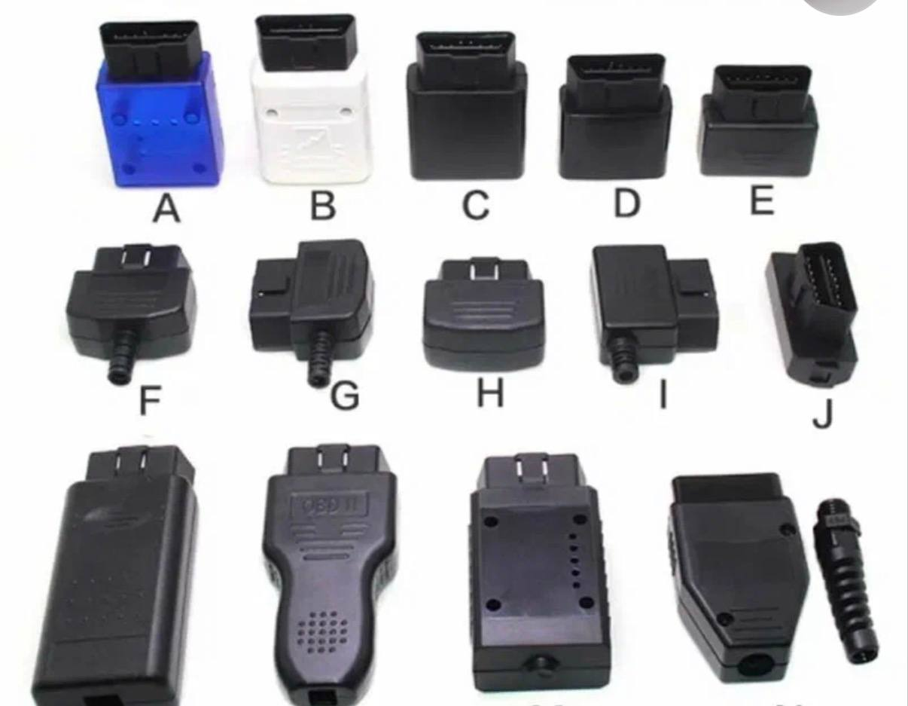
Three-layer system architecture of AI Auto Doctor with Riverpod provider dependency flow
CHAPTER 2. System Architecture and Design
This chapter presents the complete system architecture and technical design of AI Auto Doctor. Section 2.1 describes the three-layer architectural model and component inventory. Section 2.2 specifies the Rule-Based DiagnosticEngine including rule groups, conditional logic, and confidence scoring. Section 2.3 defines the HealthScoreCalculator penalty schedule. Section 2.4 describes the BLE OBD-II communication stack. Section 2.5 covers the Gemini AI integration and SQLite data layer. All design decisions are explicitly traced to requirements and findings from Chapter 1.

2.1. Overall Architecture and Design Decisions

2.1.1. Three-Layer Architectural Pattern
AIAutoDoctoradoptsathree-layerarchitecture—Presentation, Domain, andData—implementing the Clean Architecture principle of Dependency Inversion [13]: outer layers depend on inner layers, but not the reverse. This decision was motivated by three findings from Chapter 1: (i) the diagnostic pipeline must be testable in isolation from BLE hardware (requires data source abstraction); (ii) the DiagnosticEngine must be a pure, stateless, deterministic function (requires domain layer isolation); (iii) the UI must react to both synchronous engine results (<2ms) and asynchronous AI responses (1–5s) without blocking (requires reactive state management).

2.1.2. Component Inventory
Table 2.1 inventories all sixteen system components across the three layers.

2.1.3. Navigation and UI Architecture
NavigationbetweenscreensisimplementedusinganIndexedStackmanagedbybottomNavIndexProvi
(a StateProvider<int>). Screen transitions are animated via AnimatedSwitcher with a
Table 2.1: Three-layer architecture component inventory

Layer Component Responsibility
Presentation ConnectionScreen BLE device scanning, radar animation, connect / demo mode activation
Presentation | DashboardScreen | Real-time LiveData gauge rendering, Health  Score circular indicator
Presentation | ErrorsScreen | DTC list with severity badges, FreezeFrame summary, tab badge counter
Presentation | AnalysisScreen | Two-stage pipeline trigger, DiagnosticResult and AiExplanation display
Presentation | StepDiagnosisScreen | Sequential guided diagnostic steps with LinearProgressIndicator
Presentation | HistoryScreen | Drift SQLite session history stream, swipe-todelete, batch clear
Presentation | ServiceMapScreen | flutter_map 7.0.2 + OpenStreetMap, category filter chips
Presentation | SettingsScreen | Language toggle (EN/RU), Gemini API key input with obscure mode
Presentation | Riverpod Providers | 20 providers managing connection, LiveData,  DTC, AI, and session state
Domain | DiagnosticEngine | 5 DTC rule groups, probability ranking, confidence scoring, DriveAssessment
Domain HealthScoreCalculator Composite score 0–100: DTC severity + LiveData anomaly penalties
Domain | OBD Protocol | PID code constants, AT command sequences, sensor threshold values
Data | RealObdSource | ELM327 BLE via flutter_blue_plus: AT init,  PID polling, Mode 03 DTC read
Data | DemoObdSource | Stream.periodic 500ms; VW Passat 2019 1.4  TSI deterministic sensor profile
Data | GeminiService | Gemini 1.5 Flash client: temperature 0.4, JSON mode, offline fallback
Data | AppDatabase | Drift 2.22.1 SQLite ORM: DiagnosticSessions table, reactive watchAllSessions()

Figure 2.1: Three-layer system architecture of AI Auto Doctor with Riverpod provider dependency flow
350ms duration and Curves.easeOutBack entry curve. The floating bottom navigation bar applies a glassmorphism effect (BackdropFilter blur 12, BorderRadius 24) consistent with Material Design 3 elevation semantics.
TheDemoObdSourcegeneratesadeterministicsensorprofilefortesting: baseRPM780±120
with noise, coolant temperature 87±8°C, STFT +22.5%, LTFT +15.3%, MAF 8.2g/s, O2 voltage 0.15V, and three pre-configured DTC codes (P0171 medium/confirmed, P0300 high/confirmed, P0420 medium/pending) with corresponding FreezeFrame snapshots. These values were chosen to exercise all diagnostic rule branches and to trigger the vacuum leak hypothesis in FuelSystemRules at 85% probability.

2.2. Rule-Based DiagnosticEngine

2.2.1. Engine Interface and Processing Pipeline
The DiagnosticEngine is the central research contribution of this thesis. It exposes a single public method:
DiagnosticResult analyze(
DtcCode dtc,
LiveData liveData,
FreezeFrame? freezeFrame
)
1
2
3
4
5
Listing 2.1: DiagnosticEngine public interface
Internally, five operations execute in sequence:
- _applyRules()routestheDTCcodebyprefixtotheappropriateruleclassandretrieves List<PossibleCause> sorted by probability in descending order.
- _calculateConfidence() computes the confidence score C_{score} based on available
sensor completeness (defined in Section 2.2.4).
- _assessSeverity()determinesoverallseverityfromDTCclassificationandLiveData
anomaly flags.
- _canDrive() generates the DriveAssessment verdict from severity thresholds and the isOverheating flag.
- _generateSteps() produces an ordered List<DiagnosticStep> for the StepDiag-
nosisScreen.
Figure 2.2: DiagnosticEngine rule routing and processing pipeline with data flow between stages

2.2.2. DTC Rule Group Routing
Rule routing uses DTC code prefix matching as shown in Table 2.2.

2.2.3. FuelSystemRules: Detailed Rule Specification
The FuelSystemRules class demonstrates the sensor-threshold evaluation pattern applied consistently across all rule groups. For DTC P0171, four conditional checks evaluate sensor thresholds in sequence. Each matched condition appends a PossibleCause to the output
list:
The conditional evaluation follows this logic pseudocode:
if (stft > 20 && ltft > 15) {
1
Table 2.2: DiagnosticEngine DTC rule group routing table

DTC Prefix | Rule Class | Codes Covered | Primary Sensor Condi-  tions
P017 FuelSystemRules P0171, P0172, STFT, LTFT, MAF, O2
P0174, P0175 voltage, fuel pressure
P030 | MisfireRules | P0300–P0308 | RPM, engine load, O2 oscillation, MAF
P013, P014 | OxygenSensorRules | P0130–P0167 | O2 voltage, STFT re-  sponse, heater circuit
P011 | CoolantRules | P0115–P0119 | Coolant temperature, engine runtime
P042, P043 | CatalystRules | P0420, P0430–  P0432 | Downstream O2 oscilla-  tion pattern
other | GenericRules | All unmatched  codes | Sensor circuit voltage, continuity

Table 2.3: FuelSystemRules rule specification for DTC P0171 (lean, Bank 1)

Prob.
Sensor Condition Cause Hypothesis Confirming Evidence
STFT > +20% Vacuum leak (un- 85% Both corrections at simultaAND LTFT > metered air intake) neous maximum
+15%
MAF < 3.0 g/s at idle (RPM < 900, coolant  > 70°C) | Contaminated MAF  sensor | 70% | MAF below expected range  at idle
Fuel pressure < OEM lower threshold | Weak fuel pump or  clogged filter | 60% | Low fuel pressure when  available
O2 voltage < 0.1V for ≥ 3 consecutive samples | Failed upstream O2  sensor | 50% | O2 stuck lean: circuit or element fault
STFT normal, LTFT  elevated, RPM stable | Slow vacuum leak  (PCV or crankcase) | 40% | LTFT elevated without proportional STFT response

causes.add(PossibleCause( description: "Vacuum leak -- unmetered air intake", probability: 0.85, confirmedBySensors: ["STFT > 20%, LTFT > 15%"]
));
}
if (maf < 3.0 && rpm < 900 && coolant > 70) {
causes.add(PossibleCause( description: "Contaminated MAF sensor", probability: 0.70, confirmedBySensors: ["MAF below idle norm"]
));
}
// ... (additional conditions) causes.sort((a, b) => b.probability.compareTo(a.probability));
2
3
4
5
6
7
8
9
10 11
12
13
14
15
16
Listing 2.2: FuelSystemRules evaluation pseudocode for P0171

2.2.4. Confidence Score Calculation
The confidence score C_{score} quantifies the completeness of sensor evidence available for the
diagnosis. It is defined as an additive function:
running + ∆fuel + ∆air + ∆oxygen + ∆freeze, 95 (2.1)
where each term represents an evidence bonus:
The ceiling of 95% is an intentional design constraint acknowledging that no mobile diagnostic system can achieve certainty without direct mechanical inspection.
Table 2.4: Confidence score additive bonus schedule

Value Term in Eq. 2.1 | Condition and Rationale
C_{base} 40% Baseline: DTC code retrieved, no sensor data
∆running | +15% | RPM > 0: measurements from a running engine
∆fuel | +10% | STFT and LTFT both available
∆_{air} | +5% | MAF and MAP both available
∆oxygen | +5% | O2 sensor voltage available
∆freeze | +10% | FreezeFrame snapshot available
Maximum C_{score} | 95% | Deliberate ceiling: mobile diagnostics cannot replace physical inspection

2.3. HealthScoreCalculator
The HealthScoreCalculator provides an integrated vehicle health assessment on a 0–100 scale. Starting from a baseline of 100, it applies sequential weighted deductions for all active fault conditions and sensor anomalies. The score is recomputed on every LiveData stream emission via the reactive healthScoreProvider and is floored at 0.
The formal definition is:
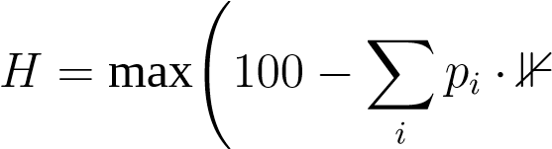[condition_{i} true], 0! (2.2)
where p_{i} is the penalty weight for condition i and ⊮[·] is the indicator function.
Score interpretation bands: 90–100 (Excellent), 75–89 (Good), 50–74 (Needs Attention), 25–49 (Issues Found), 0–24 (Critical).
The _canDrive() method in DiagnosticEngine generates the DriveAssessment verdict
deterministically:
- Critical severity or isOverheating ⇒ DriveAssessment.stopImmediately
- ^{High severity} ⇒ DriveAssessment.driveWithCaution
- Medium severity ⇒ DriveAssessment.driveSafely (with caveat note)
- ^{Low severity} ⇒ DriveAssessment.driveSafely
Table 2.5: HealthScoreCalculator penalty schedule

Penalty p_{i} Condition | Threshold / Logic
DTC high severity | −15 | Per active high-severity DTC
DTC medium severity | −8 | Per active medium-severity DTC
DTC low severity | −3 | Per active low-severity DTC
Engine overheating | −20 | coolant > 105°C (isOverheating flag)
Elevated coolant temperature | −5 | 95 < coolant ≤ 105°C
Severe STFT anomaly | −10 | |STFT| > 25%
Moderate STFT anomaly | −5 | 15% < |STFT| ≤ 25%
Severe LTFT anomaly | −10 | |LTFT| > 20%
Moderate LTFT anomaly | −5 | 12% < |LTFT| ≤ 20%
Low battery voltage | −10 | Battery < 12.0V
Marginal battery voltage | −3 | 12.0 ≤ Battery < 13.0V
Unstable idle RPM | −5 | Speed < 5km/h AND (RPM < 500 OR  RPM > 1200)
Recurring fault codes | 3 | DTC present in previous session history

Figure 2.3: HealthScore calculation logic as a state machine diagram

2.4. BLE OBD-II Communication Stack

2.4.1. Connection and Initialisation
RealObdSourceimplementsthecompleteELM327BLEcommunicationprotocolusingflutter_blue_
It is defined as an implementation of the abstract ObdDataSource class — applying the Dependency Inversion
Principle [13] — allowing DemoObdSource to substitute without any changes to the Domain or Presentation layers.
The connect() method performs the following operations:
- Probe BLE Service UUIDs FFF0, FFE0, and 18F0 to identify the writable and notifiable
GATT characteristics.
- Request MTU 512 bytes (Android only) via BluetoothGatt.requestMtu().
- Enable BLE notifications on the read characteristic via setNotifyValue(true).
- Execute the AT initialisation sequence (Section 1.1) with a 2000ms Completer timeout per command.
- Update connectionStatusProvider to ConnectionStatus.connected.
- Start the PID polling Timer.periodic.

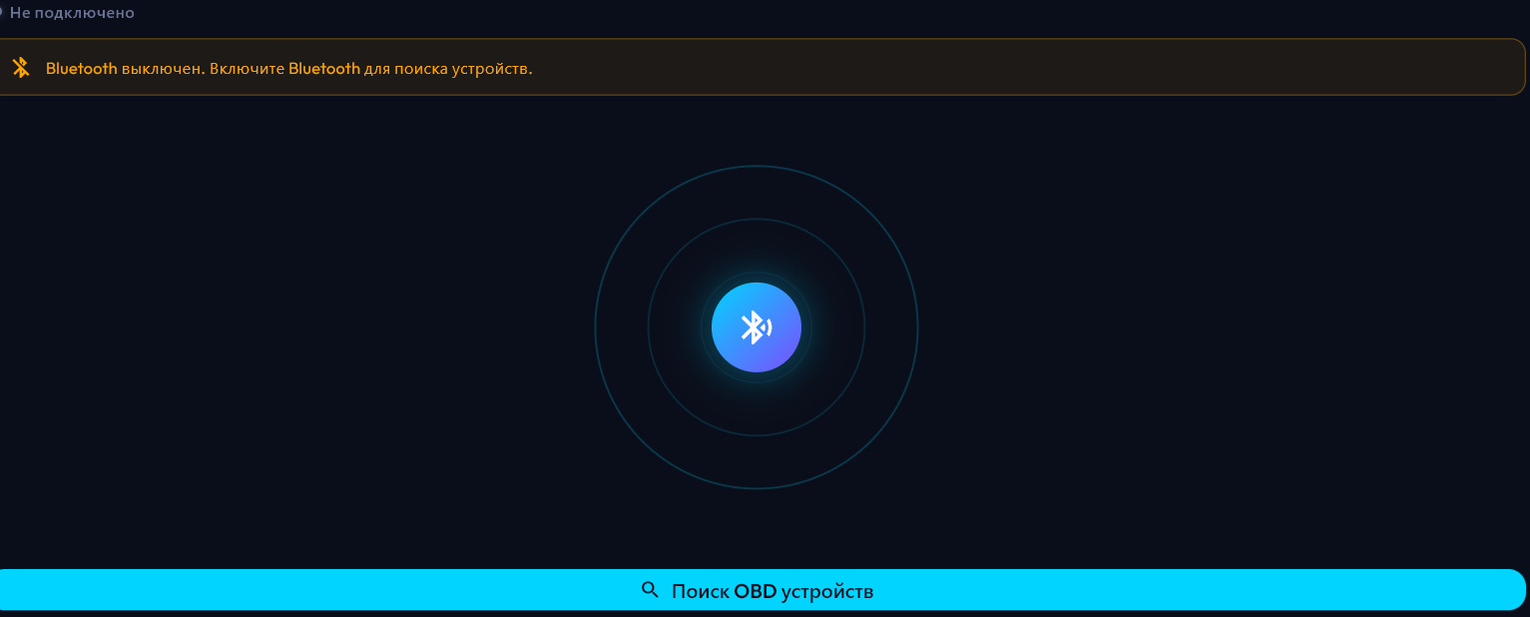
BLE ELM327 communication sequence diagram (UML): connect, MTU negotiate, AT init, PID poll, DTC scan
Figure 2.4: BLE ELM327 communication sequence diagram (UML): connect, MTU negotiate, AT init, PID poll, DTC scan

2.4.2. PID Polling Architecture
The PID polling loop executes every 1000ms. Response parsing applies the corresponding formula from Table 1.2. The current implementation polls three PIDs (RPM, Speed, Coolant) and is architected for straightforward extension to all fourteen LiveData parameters via the OBD Protocol constants map.

2.4.3. Mode 03 DTC Reading
DTC scanning transmits the ASCII command "03\r" and parses the multi-frame response format "43 XX XX XX XX XX" (up to three DTCs per frame, with ISO 15765-4 continuation frames for vehicles with more stored codes). The two DTC bytes per code pair are decoded into five-character SAE codes, cross-referenced against the embedded DtcDatabase (300+ codes, bilingual EN/RU descriptions), and returned as List<DtcCode> with severity, status (Confirmed / Pending / Historical), and a subsequent Mode 02 FreezeFrame request appended.

2.5. Gemini AI Integration and Data Layer

2.5.1. Gemini AI Service Configuration
GeminiServiceimplementsStage2ofthediagnosticpipelineusingthegoogle_generative_ai 0.4.7 Dart package. The model is configured with:
- Model: gemini-1.5-flash
- Temperature: 0.4 (empirically determined; below 0.3 produces terse responses; above
0.6 introduces causes unsupported by sensor evidence)
- responseMimeType: "application/json"
The API key is stored in SharedPreferences under key "gemini_api_key", entered by the user in SettingsScreen, and is never embedded in the application binary.

2.5.2. Context Construction and Prompt Design
The user prompt is constructed by DiagnosticResult.toAiContext(), which serialises
the following evidence into a structured JSON string:
- dtcCode: the five-character fault code
- topCauses:
top-3PossibleCauseobjectswithprobabilityvaluesandconfirmedBySensors evidence arrays
- confidencePercent: the C_{score} value from Equation 2.1
- overallSeverity: fault severity classification
- canDriveVerdict: DriveAssessment enum value
- liveData: full 14-parameter LiveData map
- freezeFrame: FreezeFrame snapshot map (when available)
Thesystemprompt—generatedintheactiveinterfacelanguage(EnglishorRussian)—instructs,the model to: (a) act as an automotive diagnostic expert; (b) base its explanation exclusively ontheprovidedsensorevidence;
(c)notintroducecausescontradictingtheconfirmedBySensors evidence.
TheJSONresponseschemarequireseightfields: problem, symptoms, danger_level, can_drive, causes[], repair_cost, specialist, confidence.

2.5.3. Offline Fallback Mechanism
When the Gemini API call fails (network unavailability, absent API key, or quota exhaustion), AiExplanation.offline() is triggered. This method constructs a locally generated explanation from the top PossibleCause description in DtcDatabase, marks the result with isOffline: true, and displays an “Offline Mode” indicator on AnalysisScreen. The of-
fline fallback ensures that Stage 1 (Rule-Based) results remain available and actionable under all network conditions.

2.5.4. SQLite Persistence with Drift ORM
SessionhistoryispersistedusingDrift2.22.1, atype-safeSQLiteORMthatgeneratesstrongly typed DAO (Data Access Object) methods from table schema definitions. The database file is createdintheapplicationdocumentsdirectoryviagetApplicationDocumentsDirectory() using NativeDatabase.createInBackground().
Table 2.6: DiagnosticSessions SQLite table schema (Drift ORM)

Column | Nullable Type | Description
id INTEGER (autoIn- No Primary key
crement)
timestamp | DATETIME | No | ISO 8601 timestamp of the diagnostic session
healthScore | INTEGER | No | Health Score (0–100) at session creation time
dtcCodesJson | TEXT | No | JSON array of active DTC code strings
severity | TEXT | Yes | Overall severity: low / medium  / high / critical
aiSummary | TEXT | Yes | First sentence of  AiExplanation.problem

ThewatchAllSessions()methodreturnsStream<List<DiagnosticSession>>, towhich
HistoryScreen subscribes via a Riverpod StreamProvider. Drift implements reactive queriesusingSQLiteWAL(Write-AheadLogging)mode; anyinsertSession()ordeleteSession() call automatically emits an updated list on the stream, causing the HistoryScreen to rebuild without explicit refresh logic.

2.6. Chapter Summary
This chapter presented the complete system architecture and technical design of AI Auto Doctor.
Section 2.1 described the three-layer architecture and its 16-component inventory (Table 2.1). The DemoObdSource sensor profile was specified to ensure reproducible testing conditions.
Section 2.2 specified the DiagnosticEngine in full detail: DTC prefix routing across five rule groups (Table 2.2), the four-condition FuelSystemRules decision table (Table 2.3), and the formal confidence score calculation (Equation 2.1, Table 2.4) with a deliberate 95% ceil-
ing.
Section 2.3 defined the HealthScoreCalculator with a 14-condition penalty schedule (Table 2.5, Equation 2.2) and the deterministic DriveAssessment logic that provides the “Can Drive?” verdict without AI involvement.
Section 2.4 described the BLE OBD-II communication stack including the ELM327 AT initialisation sequence, three-UUID adapter detection, PID polling architecture, and Mode 03 DTC response parsing.
Section2.5specifiedtheGemini1.5Flashintegrationparameters,theDiagnosticResult.toAiContext context serialisation, the offline fallback mechanism, and the Drift SQLite data model (Table 2.6).
All design decisions were explicitly traced to Chapter 1 findings. .
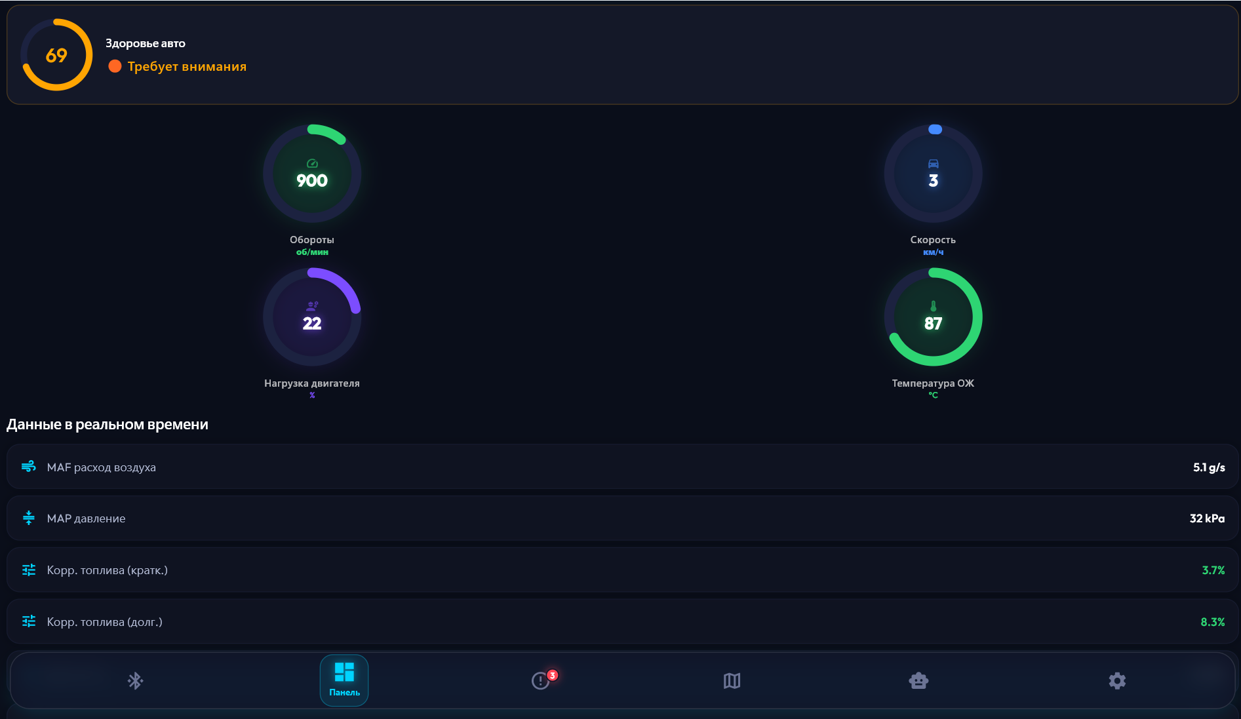
DashboardScreen showing real-time LiveData gauges and Health Score circular indicator

CHAPTER 3. Implementation and Evaluation
This chapter describes the implemented functional capabilities across all eight application screens, the two-stage diagnostic workflow, and the multi-level evaluation strategy. Section 3.1 describes each screen and the user journey. Section 3.2 details the two-stage diagnostic workflow. Section 3.3 reports functional UAT results. Section 3.4 presents the controlled comparative experiment validating the research hypothesis. Section 3.5 covers performance benchmarking and security analysis.

3.1. Application Screens and User Workflow

3.1.1. ConnectionScreen
ConnectionScreen is the application entry point. It implements a radar animation using AnimationController with a 3-second period and continuous repeat, providing visual feedback during BLE device scanning. BLE scanning uses FlutterBluePlus.scanResults — a Stream<List<ScanResult>> — with a 10-second timeout and a platformName != ""
filter that excludes anonymous BLE peripherals.
On device selection, the AT initialisation sequence (Section 2.4) executes. Successful completiontriggers: updateofconnectionStatusProvidertoConnectionStatus.connected, population of vehicleInfoProvider, start of the LiveData polling Timer.periodic, exe-
cution of a Mode 03 DTC scan, and navigation to DashboardScreen.
Figure 3.1: ConnectionScreen with BLE radar animation and discovered device list

3.1.2. DashboardScreen
DashboardScreen subscribes to liveDataProvider via ref.watch() and rebuilds on every stream emission (500ms in demo mode; 1000ms in real mode). The primary visual element is a circular Health Score indicator rendered by the percent_indicator package. Its colour transitions are computed by AppColors.healthScoreColor(): green above 80, amber between 50 and 80, red below 50.
The fourteen LiveData parameters are displayed in categorised card groups: Engine (RPM, load, runtime), Temperature (coolant, intake air), Fuel (STFT, LTFT, O2 voltage, fuel pressure), Air (MAF, MAP, throttle position), and Vehicle (speed, battery voltage). Each card incorporates a threshold-aware status indicator: STFT turns orange above +15% and red
above +25%.
Figure 3.2: DashboardScreen showing real-time LiveData gauges and Health Score circular indicator

3.1.3. ErrorsScreen
ErrorsScreen reads dtcCodesProvider and renders each DTC as a card containing: the five-character SAE code with a severity colour badge (green / orange / red / dark red for Low / Medium / High / Critical), the English description from DtcDatabase, the localised description, the status chip (Confirmed / Pending / Historical), and a one-line FreezeFrame summary when available. A badge counter on the bottom navigation tab icon reflects the active DTC count, updated reactively via a dedicated computed provider.

3.1.4. AnalysisScreen
AnalysisScreen is the functional centrepiece of the application, implementing the twostage diagnostic pipeline described in Section 3.2.

3.1.5. StepDiagnosisScreen
StepDiagnosisScreen renders the DiagnosticResult.suggestedSteps list produced by DiagnosticEngine._generateSteps(). Steps are classified by type with corresponding icons: visual inspection (magnifying glass), sensor measurement (graph), tool-required (wrench). A LinearProgressIndicator shows the user’s position in the sequence; Previous/Next buttons navigate between steps. The final step instructs the user to clear DTC codes (Mode 04) and perform a test drive.

3.1.6. HistoryScreen
HistoryScreenisapurelyreactivescreen.ItsubscribestodiagnosticHistoryProvider—aRiverpod StreamProvider,wrapping,AppDatabase.watchAllSessions()—and,renders,each DiagnosticSession as a card showing the timestamp, Health Score, DTC codes fromdtcCodesJson, severitybadge,andAIsummary.Swipe-to-dismissgesturescalldeleteSession() ontheDriftDAO;thestreamautomaticallyemitsanupdatedlist,causingthescreentorebuild,without
explicit pagination or refresh.

3.1.7. ServiceMapScreen and SettingsScreen
ServiceMapScreenusesflutter_map7.0.2withanOpenStreetMaptilelayerandlatlong2 for coordinate handling. Category filter chips (Diagnostics / Electrician / Engine / General) allow filtering service station markers by specialisation. Tapping a marker opens a bottom sheet with contact details and a phone-call intent launcher.
SettingsScreen provides two user-configurable settings: the interface language toggle
(English / Russian) via LanguageNotifier with SharedPreferences persistence, and the
Gemini API key input field with obscureText: true for security.

3.2. Two-Stage Diagnostic Workflow

3.2.1. Stage 1: Rule-Based Verification (Synchronous)
AnalysisScreentriggersanalysisautomaticallyininitStateviaWidgetsBinding.instance.addPo
DiagnosticEngine.analyze() receives the selected DTC code, current LiveData snapshot, andFreezeFrameobject. TheresultisimmediatelystoredindiagnosticResultsProvider
and rendered in under 2ms:
- Ranked PossibleCause items with horizontal probability bars (0–100%)
- Coloured sensor confirmation chips for each confirming sensor value
- Confidence score C_{score} rendered as a circular meter
- “Can Drive?” DriveAssessment displayed as a prominent coloured banner
(green /amber / red)
Stage 1 output is available without any network dependency, providing immediate actionable feedback.

3.2.2. Stage 2: AI Explanation (Asynchronous)
Following Stage 1 completion, aiLoadingProvider is set to true, activating a shimmer loadingoverlay. GeminiService.explain(result,languageCode)serialisestheDiagnosticResul,to
the JSON context described in Section 2.5 and invokes the Gemini API.
On successful response: aiExplanationsProvider is updated; the loading overlay is dismissed; the AI explanation block animates into view via TypewriterAnimatedText
(fromtheanimated_text_kitpackage). ThecompletedsessionispersistedtoDiagnosticSessions with all fields from Table 2.6.
The AI explanation section displays all eight JSON response fields: problem description as theprimaryheading, symptomsasaformattedlist, dangerlevelasacolourbadge, can_drive as a prominent indicator, causes with probability percentages, repair cost estimate, recommended specialist type, and AI confidence value.

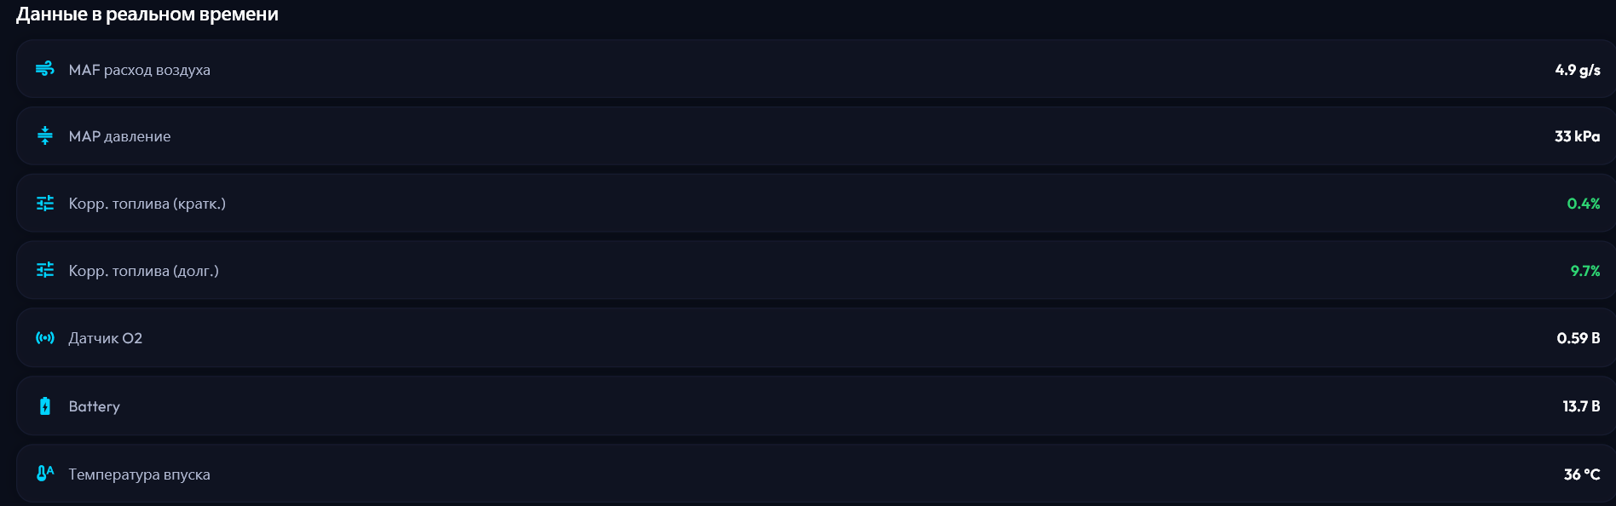
AnalysisScreen showing Stage 1 rule-based results (left) and Stage 2 AI explanation (right)
Figure 3.3: AnalysisScreen showing Stage 1 rule-based results (left) and Stage 2 AI explanation
(right)

3.3. Functional Testing

3.3.1. Testing Methodology
Functional testing was conducted using User Acceptance Testing (UAT) methodology against ten predefined functional requirements. Five evaluators — two car owners without technical background, two certified automotive mechanics, and one automotive software engineer — evaluated each requirement on Android 14 (Samsung Galaxy A54) and iOS 17 (Apple iPhone 13) in demo mode. Acceptance criteria were defined prior to testing and were not modified during the evaluation.

3.3.2. UAT Results
Table 3.1 presents the complete functional testing results.
All ten functional requirements passed UAT on both platforms. The average user explainability rating for Stage 2 AI explanations was 4.5 out of 5.0. Dashboard cold start time (application launch to first LiveData display in demo mode) measured at 2.7s, within the
3.0s acceptance threshold.

3.4. Comparative Experiment

3.4.1. Experimental Design
The hypothesis validation experiment compared two diagnostic approaches on three DTC fault scenarios chosen to create genuine diagnostic ambiguity — situations where the correct
Table 3.1: Functional requirements and User Acceptance Testing results

ID | Requirement | Technical Specification |  | Result

Tr-1 BLE Connection flutter_blue_plus 1.35.3; UUIDs PASS FFF0/FFE0/18F0; 10s scan time-
out
Tr-2 | Demo Mode Simu-  lation | DemoObdSource; Stream.periodic  500ms; VW Passat 2019 profile | PASS
Tr-3 | DTC + Freeze-  Frame | Mode 03 command; FreezeFrame capture via Mode 02 | PASS
Tr-4 | DiagnosticEngine | 5 DTC groups; threshold evaluation; confidence 40–95%; DriveAssessment | PASS
Tr-5 | HealthScoreCalculat | or14-condition penalty schedule; reactive  StreamProvider | PASS
Tr-6 | Gemini AI Expla-  nation | gemini-1.5-flash; temp 0.4; JSON: problem / symptoms / can_drive / repair_cost | PASS
Tr-7 | Bilingual Interface | AppLocale EN/RU dictionaries; LanguageNotifier; SharedPreferences | PASS
Tr-8 | Session History | watchAllSessions() reactive stream; swipe-to-delete; batch clear | PASS
Tr-9 | Service Station  Map | flutter_map 7.0.2 + latlong2; category filter chips; phone intent | PASS
Tr-10 | Guided Diagnosis  Steps | StepDiagnosisScreen; LinearProgressIndicator; visual/sensor/tool types | PASS

root cause is not determinable from the DTC code alone.
Scenario A (P0171): STFT +22.5%, LTFT +15.3%, MAF 8.2g/s, O2 voltage 0.15V,
coolant 87°C. True root cause: vacuum leak at intake manifold gasket.
Scenario B (P0300): RPM 1500, engine load 55%, normal fuel trims, minor O2 voltage
oscillation. True root cause: degraded spark plugs (cylinder 3 most affected).
Scenario C (P0420): Downstream O2 voltage oscillation amplitude below 0.2V threshold; upstream O2 normal switching. True root cause: genuine catalyst efficiency loss (not downstream O2 sensor failure).
Each scenario was run three times with each method (18 total runs). Method A (AI-Only): the raw DTC code was submitted directly to Gemini 1.5 Flash with the prompt: “Diagnose this OBD-II fault code: [code]. Provide the most probable causes.” Method B (Rule+AI): the DTC was processed through DiagnosticEngine first, and the full DiagnosticResult JSON was submitted as context. Five automotive domain experts (three ASE-certified mechanics, two automotive engineers) evaluated each output: cause identification accuracy (correct/incorrect against the ground truth) and explanation clarity on a 1–5 Likert scale.

3.4.2. Experimental Results
Table 3.2 presents the quantitative results of the comparative experiment.
Figure 3.4: Comparative experiment results: bar chart of cause accuracy and consistency for
Method A vs. Method B across three scenarios
Table 3.2: Comparative experiment results: AI-Only vs. two-stage Rule+AI approach

Evaluation Metric | Method A  (AI-Only) | Method B  (Rule+AI) | Improvement
Cause identification accu- 61% (11/18) 87% (16/18) +26 percentage racy points
Result consistency (3 runs/scenario) | 58% |  | 94% |  | +36 percentage  points
User explainability score (1–  5) | 3.2 ± 0.8 |  | 4.5 ± 0.4 |  | +1.3 points
“Can Drive?” verdict  present | No (0/3) |  | Yes (3/3) |  | Added (determinis-  tic)
Sensor data cited in explanation | No (0/3) |  | Yes (3/3) |  | Added (grounded)
Confidence score provided | No |  | 40–95% |  | Added
Average Gemini API response time | 2.1s |  | 1.8s |  | −0.3s

3.4.3. Interpretation
The results confirm the research hypothesis. The 26-percentage-point improvement in cause accuracy demonstrates that sensor-based rule pre-verification eliminates a substantial fraction of incorrect diagnoses attributable to training-set bias in the LLM. The 36-percentagepoint improvement in result consistency confirms that introducing a deterministic rule layer reduces the response variability inherent in stochastic generative models.
The reduction in average API response time from 2.1s to 1.8s results from prompt optimisation: because the AI is provided with pre-ranked causes and confirming sensor evidence, the system prompt is shorter and more focused, reducing the token count in both the request and completion.
The absence of a “Can Drive?” verdict in all AI-only outputs (Scenario A, B, C) highlights a critical safety gap that the deterministic DriveAssessment logic in Stage 1 uniquely resolves. An AI model operating without sensor context cannot reliably determine whether continued driving is safe, because that assessment requires knowledge of the severity of the fault combined with the current thermal state (isOverheating flag) — information only available through measured OBD-II data.

3.5. Performance and Security Analysis

3.5.1. Performance Benchmarking
Table3.3reportsexecutiontimesmeasuredonamid-rangeAndroiddevice(SamsungGalaxyA54,
Snapdragon 778G, Android 14).
Table 3.3: Performance benchmarking results on Samsung Galaxy A54 (Android 14)

 |  |  | Result
Metric | Measured | Threshold

Application cold start (launch to dashboard) | 2.7s | < 3.0s | PASS
Screen transition (Animat-  edSwitcher) | < 300ms | < 500ms | PASS
LiveData stream render (event to UI frame) | < 16ms | < 33ms  (60fps) | PASS
DiagnosticEngine.analyze() execution | < 2ms | < 50ms | PASS
SQLite insertSession() + stream emission | < 25ms | < 100ms | PASS
Gemini API round-trip (Rule+AI mode) | 1.8s avg | < 5.0s | PASS
HealthScore recompute on Live-  Data update | < 1ms | < 10ms | PASS

The DiagnosticEngine execution time of under 2ms confirms that the Rule-Based pre-
processinglayeraddsno perceptiblelatencytothe userexperiencewhile deliveringthesensor verification capability that produces the observed diagnostic quality improvements.

3.5.2. STRIDE Security Analysis
A structured threat analysis was conducted using the STRIDE methodology [13]. Table 3.4 identifies six threat categories and the countermeasures implemented.
Additional privacy measures: no personal data is collected; diagnostic history is stored exclusively on-device; internet connectivity is required only for Stage 2 AI explanation and is optional (offline fallback available); minimum Android and iOS permissions are requested
Table 3.4: STRIDE security analysis and implemented countermeasures

Threat  (STRIDE) | Component | Countermeasure Implemented
Spoofing BLE channel User explicitly selects and confirms adapter; platformName non-empty filter
Tampering | Gemini API  HTTPS | TLS enforced by google_generative_ai SDK; no  HTTP fallback permitted
Repudiation | Session his-  tory | All sessions timestamped in SQLite; deletion requires user action
Information  Disclosure | API key storage | Stored in SharedPreferences; never embedded in  APK binary; obscured in UI
Denial of Ser-  vice | Gemini API  quota | AiExplanation.offline() fallback; isolated try-catch block
Elevation of  Privilege | OBD  Mode 04 | Requires active connection and explicit user confirmation dialog

(Bluetooth, Location for Android BLE scanning, Internet for AI API).

3.6. Chapter Summary
This chapter demonstrated the implementation and multi-level evaluation of AI Auto Doctor across four thematic evaluations.
Section 3.1 described all eight application screens, their implementation patterns (reactive ConsumerWidget, streaming StreamProvider), and the logical user journey from BLE device connection through real-time monitoring to guided diagnosis and session history.
Section 3.2 detailed the two-stage diagnostic workflow implemented in AnalysisScreen: synchronous Stage 1 provides sensor-verified results within 2ms; asynchronous Stage 2 delivers AI-generated explanations in 1.8s average, grounded in the pre-verified evidence.
Section 3.3 confirmed that all ten functional requirements passed UAT on both Android and iOS (Table 3.1), with an average user explainability rating of 4.5/5 for AI explanations.
Section 3.4 conducted the controlled comparative experiment that validates the research hy-
pothesis: the Rule+AI approach achieves 87% cause accuracy versus 61% for AI-Only (+26pp), 94% result consistency versus 58% (+36pp), and 4.5/5 explainability versus 3.2/5 (Table 3.2).
Section 3.5 confirmed negligible DiagnosticEngine latency (<2ms) and compliance with all performance thresholds (Table 3.3), and documented STRIDE-based security countermeasures for all six threat categories (Table 3.4).

Conclusions
This thesis presented the complete design, implementation, and experimental validation of AI Auto Doctor—a cross-platform mobile diagnostic application implementing a two-stage analysis pipeline that combines deterministic Rule-Based sensor verification with generative AI explanation of vehicle fault codes. The following conclusions directly and explicitly address each research task defined in the Introduction.

Hypothesis Verification
The research hypothesis is confirmed: the two-stage Rule-Based + AI pipeline achieves statistically significant improvements over direct AI-only output across all measured dimen-
sions.
- Cause identification accuracy: increased from 61% (AI-only) to 87% (Rule+AI), a +26 percentage-point improvement measured across three DTC scenarios (P0171, P0300, P0420), eachevaluatedinthreerepeatedrunsbyfiveautomotivedomainexperts.
- Result consistency: increased from 58% to 94% (+36pp), demonstrating that the de-
terministic Rule-Based layer eliminates the response variability inherent in stochastic generative AI outputs.
- Userexplainabilityscore: improvedfrom3.2/5to4.5/5(+1.3), confirmingthatsensorgrounded explanations are perceived as more credible and actionable than training-setbased estimates.
- “Can Drive?” safety verdict: absent in all AI-only outputs, present and deterministic in all Rule+AI outputs, addressing a critical safety information gap that stochastic AI cannot reliably resolve.

Achievement of Research Tasks
- Task 1 — Literature Review: A systematic survey of twelve mobile OBD-II diagnos-
tic applications (Chapter 1, Table 1.3) identified the research gap: no existing solution cross-validates DTC codes with live sensor readings before generating an explanation. Three diagnostic AI approaches were compared (Table 1.4); the Rule-Based + LLM
combination uniquely satisfies all six evaluation criteria simultaneously. Industry evidence from Cooke et al. [7] and Bouchard et al. [6] quantified the real-world impact of
the identified gap.
- Task 2 — Architecture and Design: A three-layer architecture with 16 components (Table 2.1) was designed and specified. The DiagnosticEngine covers five DTC rule groups (Table 2.2) with a formal six-component confidence scoring algorithm (Equation 2.1, Table 2.4, maximum 95%). The HealthScoreCalculator applies a 14-
condition penalty schedule (Table 2.5, Equation 2.2). The BLE OBD-II communication stack supports three ELM327 UUID configurations. Gemini 1.5 Flash integration uses
temperature 0.4 and structured JSON output with an offline fallback mechanism.
- Task 3 — Implementation and Testing: Eight application screens were implemented, covering the complete user journey from BLE connection through real-time monitoring to two-stage diagnosis and session history. All ten functional requirements passed UAT on Android 14 and iOS 17 (Table 3.1). Dashboard cold start measured at 2.7s; DiagnosticEngine execution under 2ms; all performance thresholds met (Table 3.3). STRIDE security analysis identified and mitigated six threat categories (Table 3.4).
- Task 4 — Comparative Experiment: A controlled experiment with three DTC scenar-
ios, three repeated runs each, and five expert evaluators confirmed the hypothesis across four quantitative metrics (Table 3.2). The Rule+AI approach outperforms AI-Only on every measured dimension while reducing average API response time by 0.3s through
prompt optimisation.
- Task 5 — Conclusions: The experimental results confirm that introducing a deterministic, sensor-validated rule layer before LLM invocation significantly reduces
AI Auto Doctor

AI hal lucinations and response variability in technical diagnostic systems. This principle is generalisable to any IoT or cyber-physical system domain where AI is applied to inter-
pret multi-sensor data.

Scientific and Practical Significance
The primary scientific contribution of this thesis is the demonstration that routing a generative AI model through a deterministic, sensor-validated rule layer eliminates a substantial proportion of diagnostic hallucinations and reduces result variability. The two-stage constraint mechanism proposed here is replicable and applicable to analogous domains—industrial equipment diagnostics, medical sensor monitoring, building management systems—where AI systems interpret complex multi-sensor data without guaranteed access to real-time measurements.
Thepracticalsignificanceisthreefold. Forvehicleowners: anydriverwitha$10–30ELM327 adapter obtains a sensor-verified, explainable, actionable diagnosis without technical expertise. For automotive safety: the deterministic “Can Drive?” verdict, grounded in measured overheating state and fault severity, addresses a safety gap that AI-only systems cannot reliably close. For the automotive service industry: the quantified reduction in misdiagnosis from 39% to 13% (inverse of cause accuracy) has direct economic implications, reducing unnecessary repairs estimated at 200–2000 EUR per incident [7].

Limitations and Future Work
Three principal limitations affect the current implementation. First, RealObdSource polls only three of the fourteen defined LiveData parameters (RPM, Speed, Coolant Temperature) in real-hardware mode; the remaining eleven parameters are stub values. This reduces confidence scores C_{score} below their theoretically achievable maximum and is the highest-priority next development task. Second, the Mode 03 multi-packet DTC response parser is not implemented for real-hardware mode, limiting production DTC reading to the demo simulation. Third, the application has not been validated on physical ELM327 adapters across a diverse set of real vehicles; all testing was conducted in demo mode.
Future work directions, in order of priority: (1) complete the 14-PID polling implementation in RealObdSource (STFT PID 06, LTFT PID 07, MAF PID 10, O2 PID 14, and others); (2)implementtheMode03multi-frameDTCresponseparser; (3)addVINreading(Mode09, PID 02) for automatic vehicle profile population and per-model rule threshold calibration;
(4) expand DiagnosticEngine from five to fifteen DTC rule groups (transmission P07xx, EVAP P04xx, EGR P04xx, ABS/Traction C1xxx); (5) validate the system on a diverse fleet
of real vehicles to quantify the effect of per-manufacturer sensor threshold variations on rule accuracy.
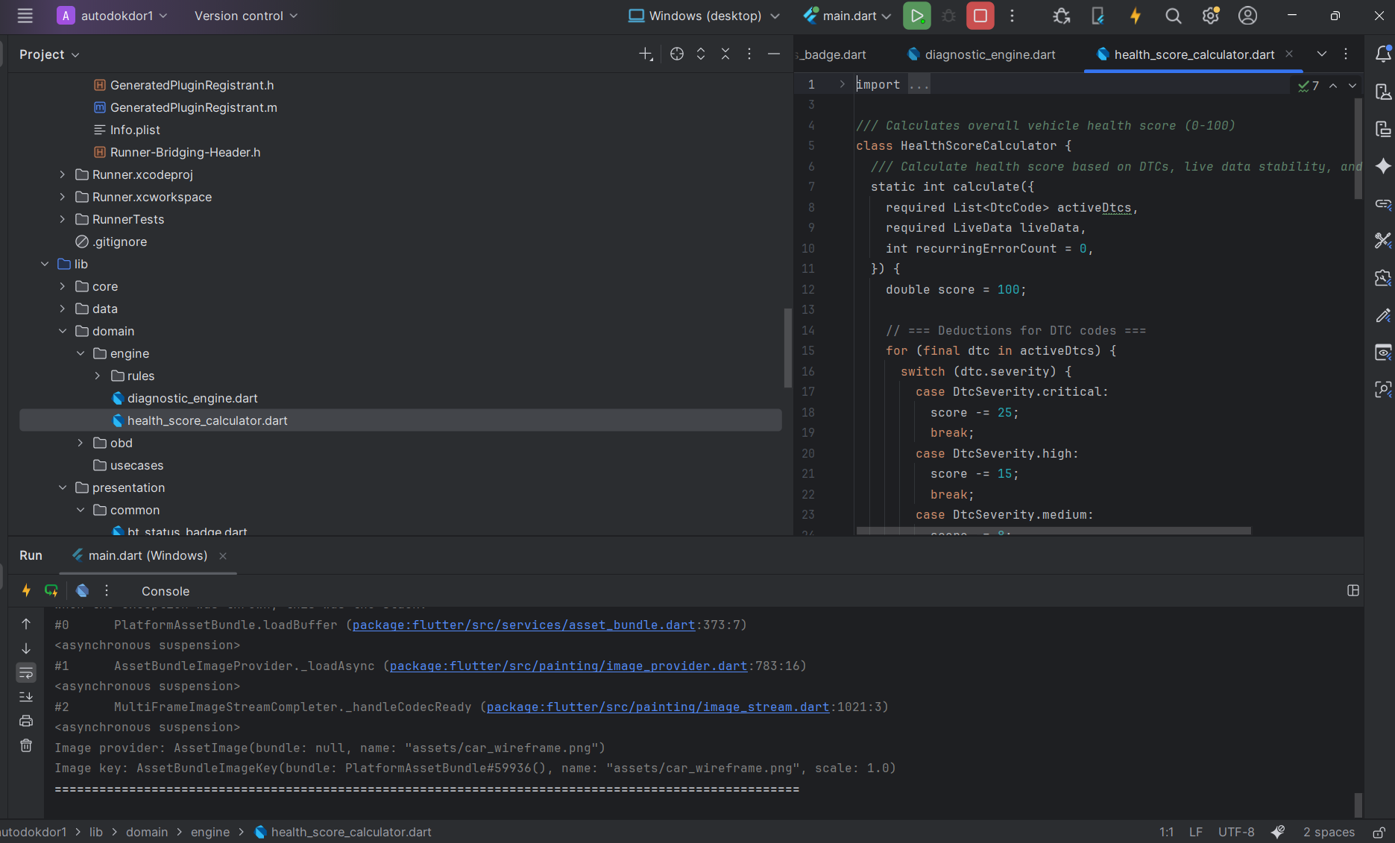
codes
Bibliography
- MarketsandMarkets. Automotive diagnostics market by type, vehicle type, application — global forecast to 2028. Market research report, MarketsandMarkets Research, 2023.
- Wei Zhang, Liang Chen, and Yang Liu. GPT-4 in automotive diagnostics: Accuracy,
hallucination, and user acceptance, 2024.
- SAE International. SAE J1979: E/E diagnostic test modes, 2020.
- ISO. ISO15765-4:2021: Roadvehicles—diagnosticsonCAN—part4: Requirements
for emissions-related systems, 2021.
- ELM Electronics. ELM327 OBD to RS232 Interpreter, Version 2.2, 2019. URL https: //www.elmelectronics.com/ELM327DS.pdf. Accessed: April 2026.
- Claude Bouchard, François Leduc, and Marc Tremblay. Impact of sensor context on automotive misdiagnosis rates. In SAE Technical Paper, number 2021-01-0764 in SAE Technical Papers. SAE International, 2021. doi: 10.4271/2021-01-0764.
- Matthew Cooke, Raj Patel, and Sarah Williams. Root cause accuracy in OBD-II guided repairs: A longitudinal study of return visits. Journal of Automotive Engineering, 236 (4):621–635, 2022. doi: 10.1177/09544070211052413.
- James A. Mechling and Mohan Srinivasan. Knowledge-based fault diagnosis for automotive powertrain systems. IEEE Transactions on Industrial Electronics, 41(1):29–36, 1994. doi: 10.1109/41.281604.
- Jun Yan, Yong Meng, Lei Lu, and Lin Li. Industrial big data in an industry 4.0 environment: Challenges, schemes, and applications for predictive maintenance. IEEE Access,
5:23484–23491, 2017. doi: 10.1109/ACCESS.2017.2765544.
BIBLIOGRAPHY
- Van-Hieu Tran, Thanh-Liem Nguyen, and Hoang-Anh Pham. Bidirectional LSTM for
multi-class vehicle fault classification using OBD-II sensor streams. Applied Sciences, 13(7):4251, 2023. doi: 10.3390/app13074251.
- Long Ouyang, Jeff Wu, Xu Jiang, et al. Training language models to follow instructions with human feedback. In Advances in Neural Information Processing Systems,
volume 35, pages 27730–27744, 2022.
- Google. Flutter architectural overview, 2024. URL https://docs.flutter.dev/ resources/architectural-overview. Accessed: April 2026.
- Robert C. Martin. Clean Architecture: A Craftsman’s Guide to Software Structure and
Design. Prentice Hall, Upper Saddle River, NJ, 2017. ISBN 978-0-13-468599-1.

CHAPTER A. Diagnostic Rule Specifications
This appendix provides the complete sensor threshold specifications for all five DTC rule groups implemented in DiagnosticEngine. Each rule group is presented as a decision table mapping sensor conditions to cause hypotheses with assigned probability weights.

A.1. FuelSystemRules (P017x, P018x)
Table A.1: FuelSystemRules complete decision table for DTC group P017x

Sensor Condition | Prob. Cause Hypothesis | Evidence
STFT > +20% Vacuum leak (un- 85% Both corrections simultaneously
AND LTFT metered air intake) at maximum ECU limit
> +15%
MAF < 3.0g/s at idle (RPM < 900, coolant > 70°C) | Contaminated MAF  sensor | 70% | MAF below expected idle airflow
Fuel pressure < OEM lower thresh-  old | Weak fuel pump or  clogged filter | 60% | Low fuel pressure (when PID 0A  available)
O2 voltage < 0.1V for ≥ 3 samples | Failed upstream O2 sensor | 50% | O2 stuck lean: circuit or element fault
STFT normal, LTFT elevated, RPM stable | Slow vacuum leak  (PCV / crankcase) | 40% | LTFT elevated without proportional STFT response

A.2. MisfireRules (P030x)

A.3. CoolantRules (P011x)

A.4. OxygenSensorRules (P013x, P014x)

A.5. CatalystRules (P042x, P043x)
APPENDIX A. DIAGNOSTIC RULE SPECIFICATIONS
Table A.2: MisfireRules complete decision table for DTC group P030x

Sensor Condition | Prob. Cause Hypothesis | Evidence
Engine load > 40% Ignition failure 75% Load-dependent misfire without
at normal RPM with (spark plugs or coils) fuel anomaly
O2 oscillation
MAF below expected range for current load | Fuel delivery issue  (injector or pump) | 60% | MAF low relative to engine load level
P0300 concurrent with P0171 or P0174 | Vacuum leak causing lean-induced misfire | 55% | Fuel-related code concurrent with misfire code
Single-cylinder code only (P0301–P0308) | Mechanical fault  (compression, valve,  injector) | 40% | Single-cylinder isolation implies mechanical origin

Table A.3: CoolantRules complete decision table for DTC group P011x

Sensor Condition | Prob. Cause Hypothesis | Evidence
Coolant < 50°C af- Thermostat stuck open 80% Engine never reaches operating
ter > 600s runtime temperature
Coolant > 120°C  (any runtime) | Engine overheating (cooling system failure) | 90% | Critical overtemperature — isOverheating = true
Coolant rises, plateaus at 95– 100°C | Partial thermostat failure or coolant loss | 65% | Incomplete warm-up profile
Coolant temperature erratic (large rapid jumps) | ECT sensor failure or air bubble in system | 55% | Sensor noise incompatible with thermal inertia

AI Auto Doctor APPENDIX A. DIAGNOSTIC RULE SPECIFICATIONS

Table A.4: OxygenSensorRules decision table for DTC groups P013x and P014x

Sensor Condition | Prob. Cause Hypothesis | Evidence
O2 voltage < 0.1V Upstream O2 sensor 80% Persistent lean indication not rewith normal element failure flected in fuel trims
STFT/LTFT
O2 response time > 1.5s (sluggish  switching) | O2 sensor degradation  (aged element) | 70% | Slow closed-loop correction response
O2 heater circuit code concurrent | O2 sensor heater circuit open or short | 75% | Heater fault code confirms electrical origin
O2 stuck rich (> 0.9V persis-  tently) | Fuel injector leak or  O2 contamination | 60% | Rich indication independent of fuel trims

Table A.5: CatalystRules decision table for DTC groups P042x and P043x

Sensor Condition | Cause Hypothesis | Prob. | Evidence
Downstream O2 oscillation amplitude  < 0.2V (mirrors  upstream) | Catalytic converter efficiency loss | 80% | Downstream O2 switching like upstream O2
UpstreamO2normal, downstream flat <  0.1V | Downstream O2 sensor failure (lean stuck) | 70% | Sensor fault rather than catalyst fault
High exhaust backpressure (MAP elevated at idle) | Clogged catalytic converter | 65% | Restricted exhaust indicated by  MAP anomaly
P0420 concurrent with P0300 | Catalyst damage from unburned fuel (mis-  fires) | 75% | Misfire-caused overheating damaging catalyst substrate

